Project 5: Recognition using Deep Networks - Report

# Short Description

TODO

# Task 1

* A - Image of the first two example digits

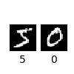

* C - The output of the python program is in the file out.txt in the task1 folder.
* D - Training and testing accuracy graph

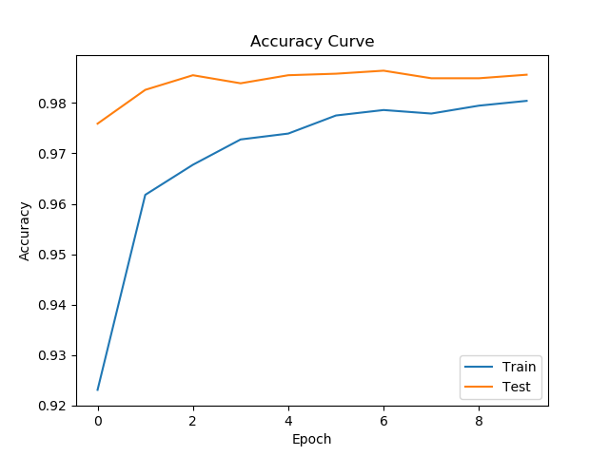

* E - The model is saved in the file my_model.h5 in the task1 folder. This is the summary of the model 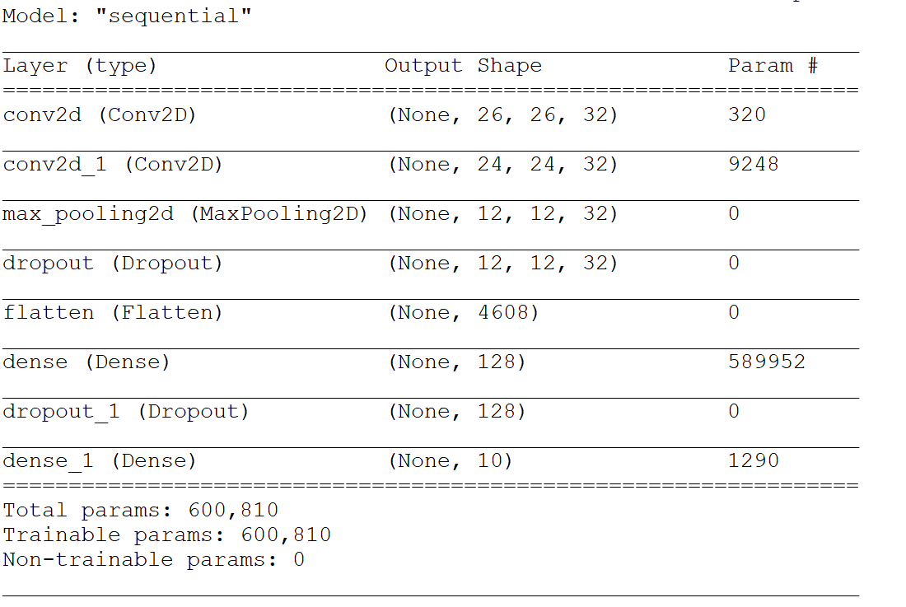
* E - The output for the first 10 test images (can be found at the end of out.txt file) 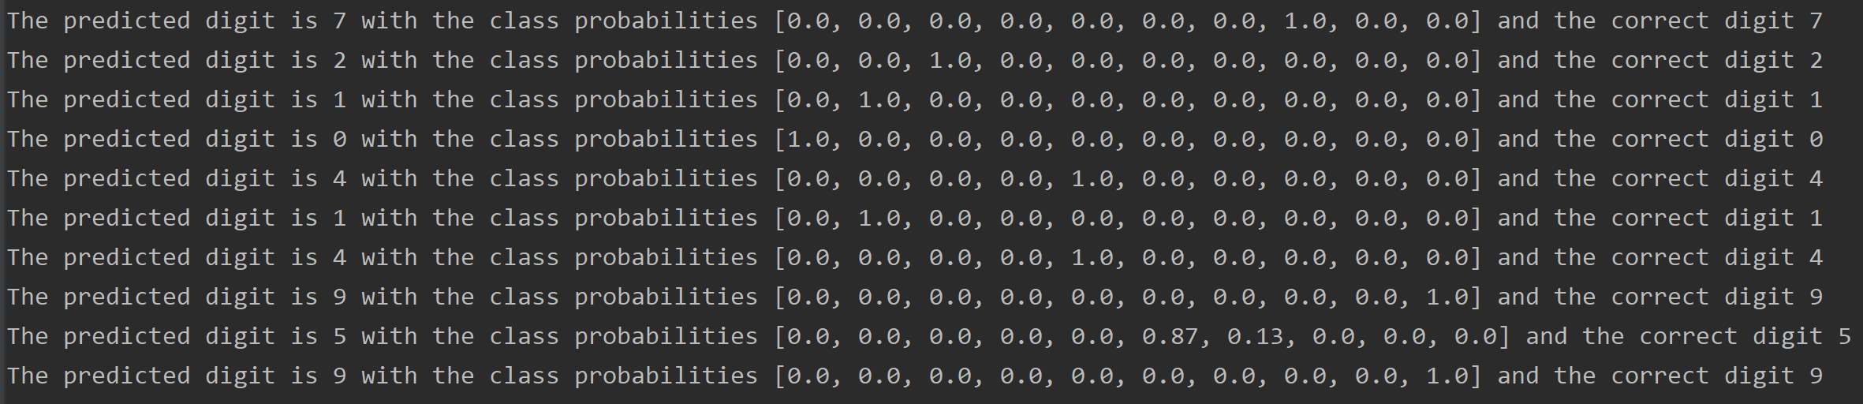
* F - The output for custom test files (can be found at the end of out.txt file)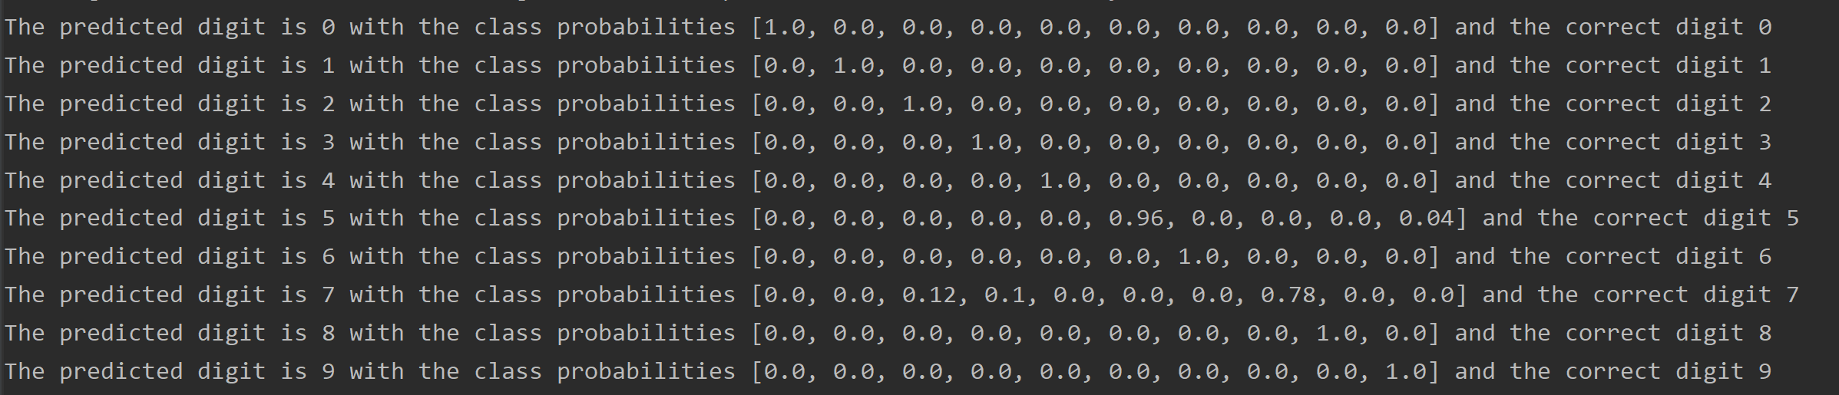
* F - These are the custom files used 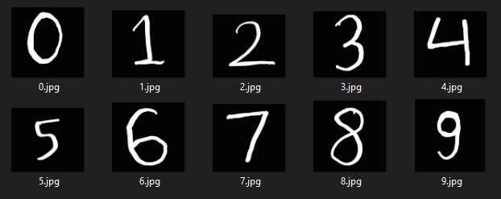

# Task 2

* B - The weights of the first layer when plotted 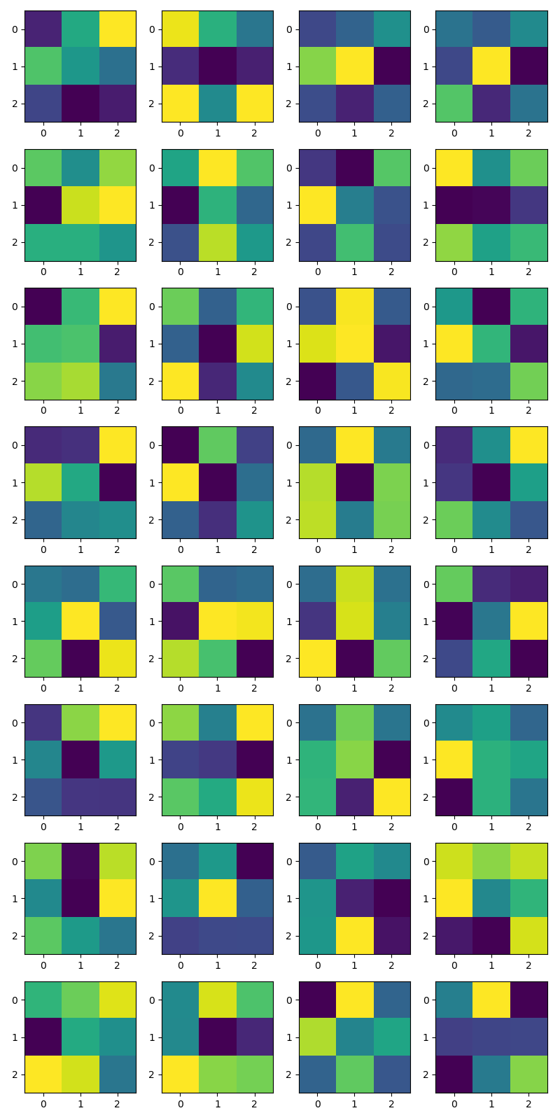
* B - The values of the weights of the first layer (compare to the plots in a row major order).

[[-0.09646592 0.04388453 0.15326902]

[ 0.0765382 0.02255454 -0.0220204 ]

[-0.0662495 -0.12421463 -0.10294966]]

[[ 0.06694997 0.02106617 -0.01238082]

[-0.04875608 -0.06645638 -0.05442373]

[ 0.07118979 -0.00064594 0.07121831]]

[[-0.03179614 -0.01371307 0.01871933]

[ 0.0751766 0.1070129 -0.06988493]

[-0.02794624 -0.05330068 -0.01591975]]

[[-0.00336326 -0.01542271 0.00887306]

[-0.02419522 0.0750742 -0.05191009]

[ 0.04108505 -0.03736936 -0.00373846]]

[[ 0.06942571 0.01673607 0.08762891]

[-0.08547939 0.10484221 0.12150645]

[ 0.04471939 0.04531214 0.02243523]]

[[ 0.00790377 0.14710456 0.05590374]

[-0.18805197 0.02881619 -0.07646387]

[-0.10503182 0.11252618 -0.00626615]]

[[-0.03733929 -0.06246521 0.05184721]

[ 0.09292512 0.00371196 -0.02318851]

[-0.02957212 0.04573593 -0.02689629]]

[[ 0.08347263 0.00710922 0.04888682]

[-0.06928213 -0.06712811 -0.04458132]

[ 0.05804966 0.0179424 0.03436492]]

[[-0.14164783 0.01772071 0.09429454]

[ 0.02270898 0.0273172 -0.12388757]

[ 0.0519858 0.063219 -0.04626216]]

[[ 0.11960521 -0.0979156 0.06538083]

[-0.09859669 -0.24353638 0.19415544]

[ 0.22560768 -0.19195244 -0.01826039]]

[[-0.03270433 0.05751356 -0.02899747]

[ 0.05249178 0.05878052 -0.05648655]

[-0.06378205 -0.02992551 0.05741747]]

[[ 0.01055213 -0.08032571 0.03054798]

[ 0.08992142 0.03171091 -0.07000522]

[-0.02302068 -0.02007564 0.05382502]]

[[-0.09877044 -0.09376534 0.15926546]

[ 0.12622873 0.0426769 -0.13386603]

[-0.03830044 0.0005558 0.01044799]]

[[-0.09935918 0.09256721 -0.05004956]

[ 0.15412566 -0.09922141 -0.00762783]

[-0.02028011 -0.06491474 0.03086017]]

[[-0.0374957 0.05133113 -0.02829271]

[ 0.03627348 -0.08342738 0.02461814]

[ 0.03776312 -0.02705222 0.02357564]]

[[-0.06577425 0.00817384 0.10726909]

[-0.05912755 -0.0900782 0.02161041]

[ 0.06319723 0.00501799 -0.03620623]]

[[-0.00957911 -0.01171827 0.00522501]

[-0.00063575 0.02340971 -0.01617041]

[ 0.01051049 -0.03139581 0.02173098]]

[[ 0.04304597 -0.05139913 -0.04517453]

[-0.11304355 0.1001932 0.0961825 ]

[ 0.07525034 0.03500593 -0.12374169]]

[[-0.05772569 0.10223331 -0.05292481]

[-0.1158317 0.10758803 -0.03627886]

[ 0.12484387 -0.15922669 0.05654709]]

[[ 0.07712019 -0.0456727 -0.05322045]

[-0.06753602 0.00676985 0.12294096]

[-0.0273067 0.04569406 -0.06974021]]

[[-0.08482764 0.11095347 0.16193596]

[ 0.00466504 -0.12918708 0.02686302]

[-0.05240298 -0.08274443 -0.08391188]]

[[ 0.05563399 -0.02077902 0.0887783 ]

[-0.06546367 -0.07275677 -0.10471006]

[ 0.03919862 0.01323379 0.08321404]]

[[-0.029216 0.03728519 -0.02692805]

[ 0.01538299 0.04294206 -0.08998539]

[ 0.01631729 -0.07533216 0.07197212]]

[[-0.00447867 0.0041965 -0.01814256]

[ 0.04414186 0.01093728 0.00576189]

[-0.04877922 0.0108035 -0.01282634]]

[[ 0.0394453 -0.09388102 0.05484745]

[-0.01664339 -0.09709735 0.07203701]

[ 0.02923425 -0.00480235 -0.03045583]]

[[-0.00315184 0.01324891 -0.03827322]

[ 0.01157081 0.057239 -0.00890754]

[-0.01990899 -0.01715852 -0.01670283]]

[[-0.01207178 0.02522201 0.01175946]

[ 0.01815844 -0.03748189 -0.04913823]

[ 0.01919696 0.07966689 -0.04274692]]

[[ 0.06260698 0.04022792 0.05969131]

[ 0.08051697 -0.04276967 0.00042766]

[-0.13635209 -0.1515193 0.06544473]]

[[-0.00123935 0.01510054 0.03933048]

[-0.09087242 -0.00730406 -0.022687 ]

[ 0.04579875 0.03619427 -0.03718005]]

[[-0.01896643 0.07036304 0.02806736]

[-0.0206453 -0.11174268 -0.09047304]

[ 0.08236261 0.04759531 0.04187178]]

[[-0.09846691 0.08906594 -0.03791817]

[ 0.06689656 -0.01355527 0.0117174 ]

[-0.03901952 0.04356601 -0.04781342]]

[[ 0.0056793 0.06581161 -0.03965715]

[-0.02002333 -0.01793327 -0.01748182]

[-0.04000673 0.0035089 0.04662318]]

* C - The effect of the filter to the first example 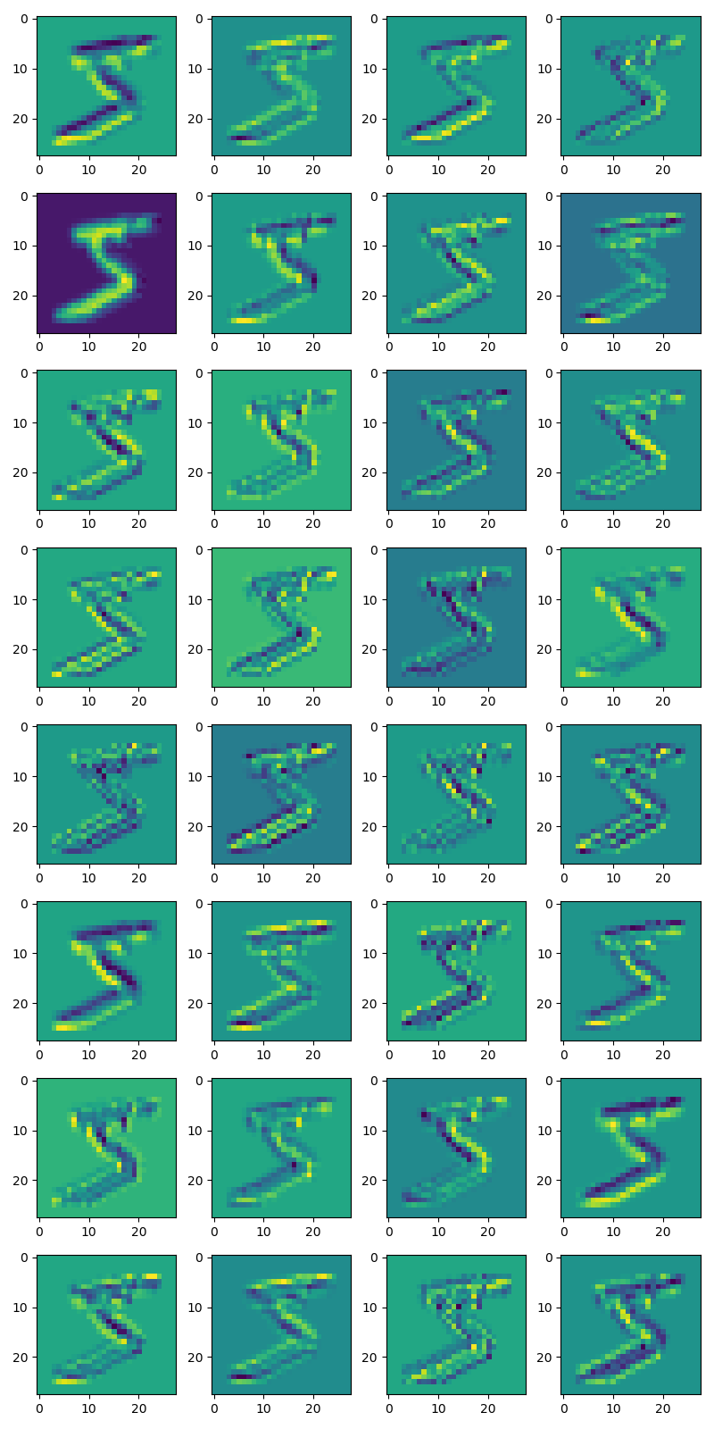

The bluer the color the more negative the value is, the yellower it is the more positive it is, and green is in the middle. This can be confirmed from the filter values.

Keeping the above convention in mind these results do make sense. Why? Because we can see that most of these filters are trying to detect some kind of edge like features. Take the third kernel in the first row for example, it has smaller values on the bottom right corner and higher values in the middle, so it can be roughly thought of as a filter which would detect edges at a 45 degree angle with the x-axis, and if we look at the corresponding filtered output, that is exactly what we see.

A lot of the kernels can be explained in a similar fashion, though not all, as some of the kernels just seem to have random patterns which don’t look anything like edge detectors, but still the outputs seem to make sense for most of these cases too.

* D - The output of the truncated model 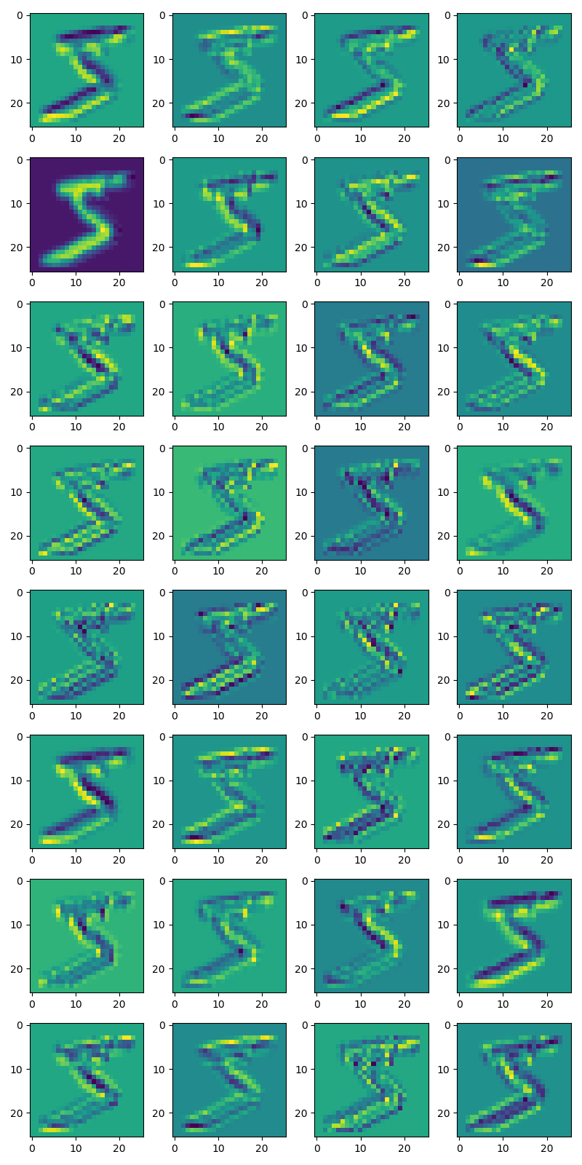

The results of applying the truncated model of just the first layer is the exact same as the output by applying the filters using the open cv functions. This is because the model is essentially doing the same thing, that is applying those filters over the image i.e. convolving the filters with the image. The only difference between both the outputs is that the output of the model is a little roomed in towards the center of the image. This is because we’re not doing any padding while applying the convolution layer, which results in the edges of the images being chopped off a little.

* E - The output after the second conv layer and the pool layer respectively 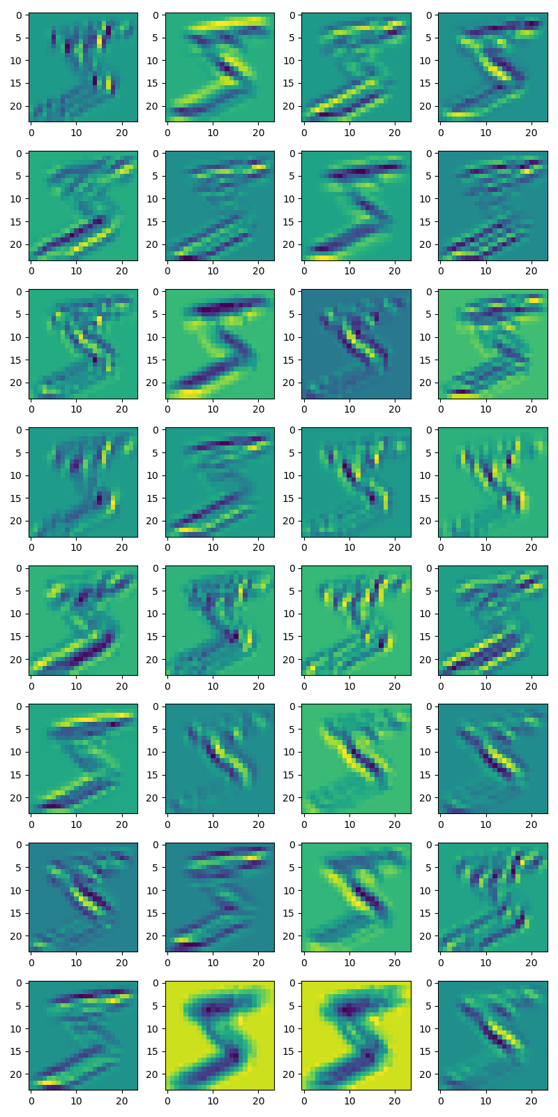 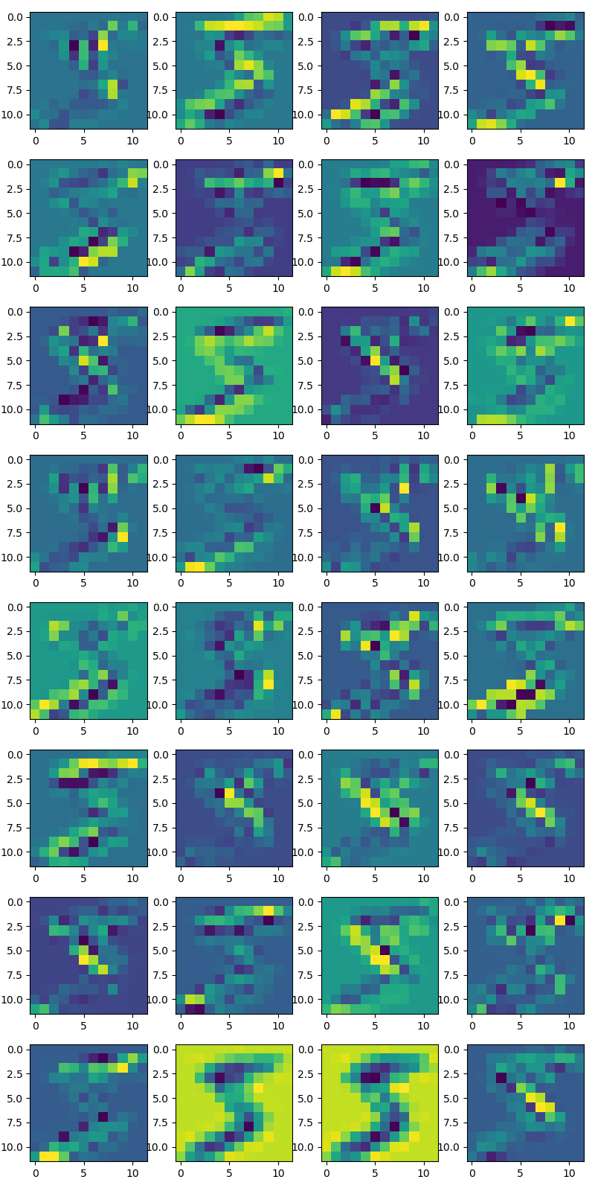
* E – More pool layer outputs 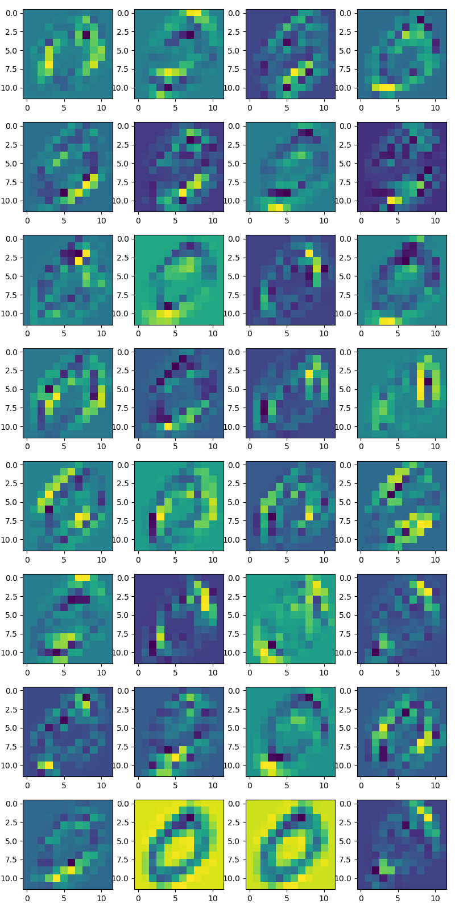 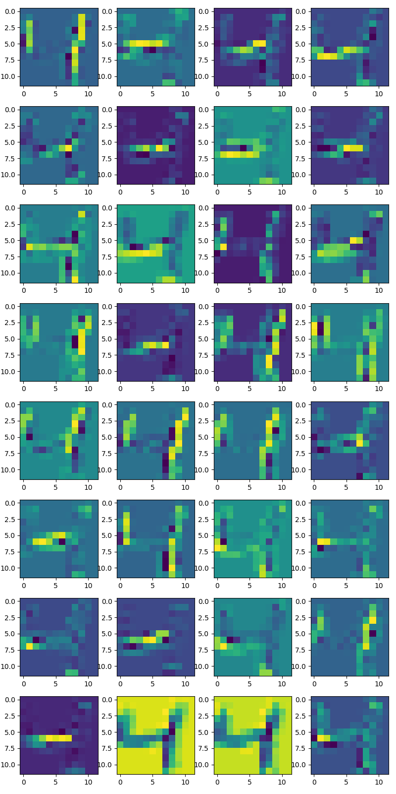 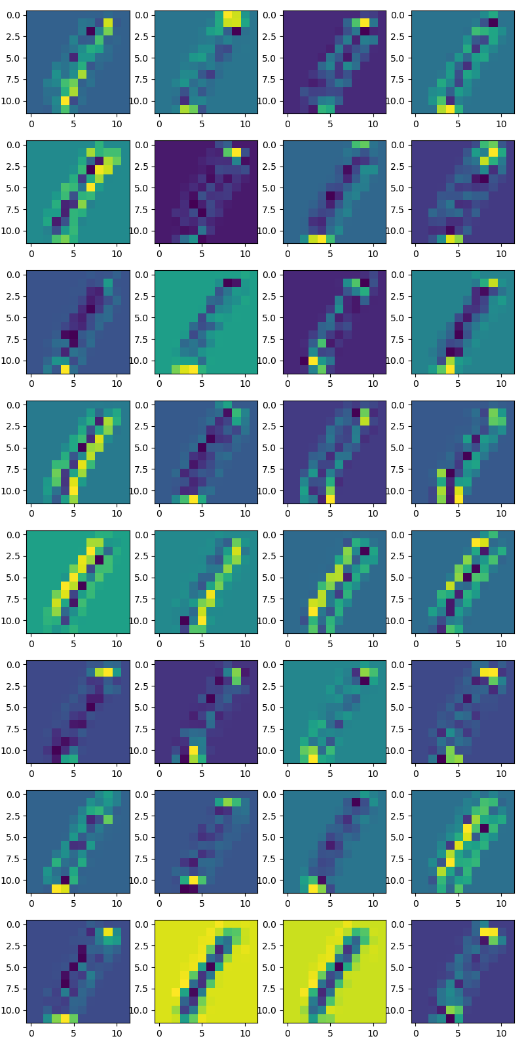 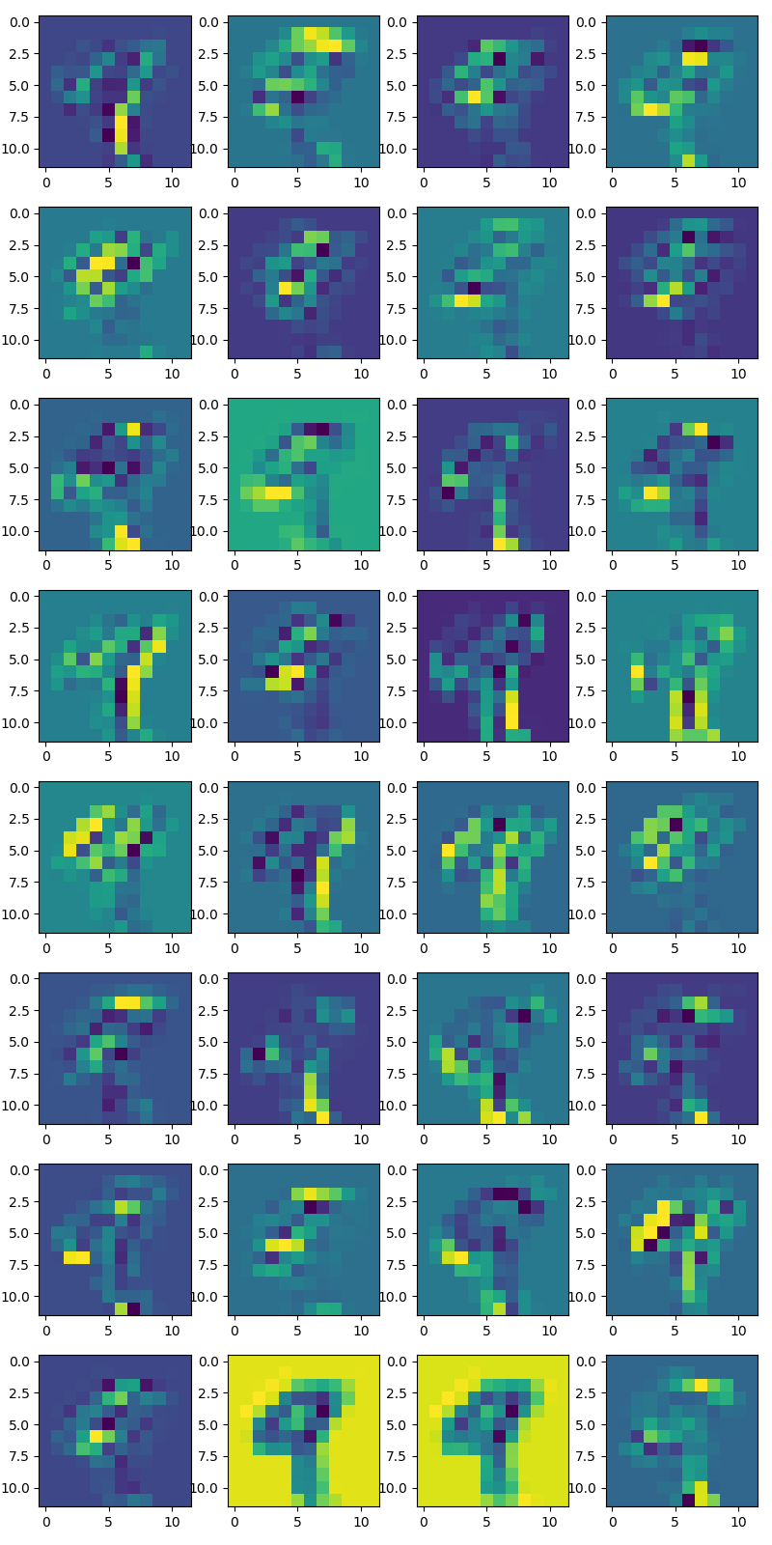 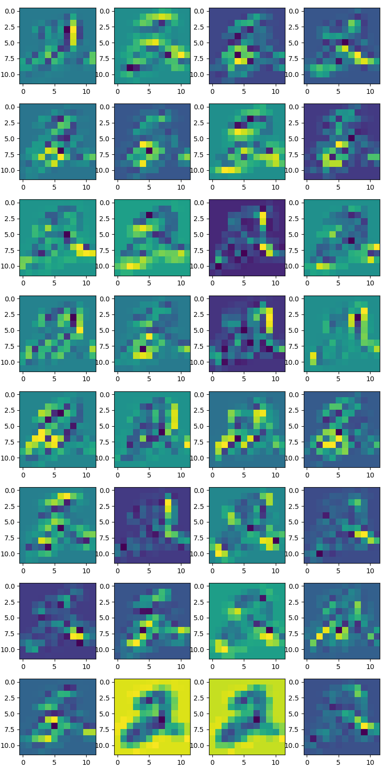

Looking at these outputs it seems like the output of most of the filters correspond to detecting a localized feature like detecting a vertical edge towards the right side of the image or detecting a round curve in the bottom right side of the image or horizontal edges at the top side of the image. For example – look at the outputs in the last column of the fifth row, it only lights up for the digits 5 and 0 (and very little in 2 as well) and that too only for the curvature in the bottom right quarter of the images, so it may be concluded that it’s detecting the curvature in the bottom right quarter of the inputs. Similar conclusions can be made for most other outputs as well.

# Task 3

* A – The file DataMaker.py contains the code for this part. The way this code is written it'll work with any number of categories and any number of examples. Provided that the files have are following the naming convention category name followed by an underscore, the rest could be anything. All you have to do is add in those files in the folder greek inside the task3 folder.
* B – to prove that the output is of size 128 we can do two things, one is to look at the model summary and verify that the last layer is a dense layer with 128 nodes or we can pass one example through the model and look at the shape of the output. Both are pasted below and can also be found in the out.txt file for task3 The model summary: 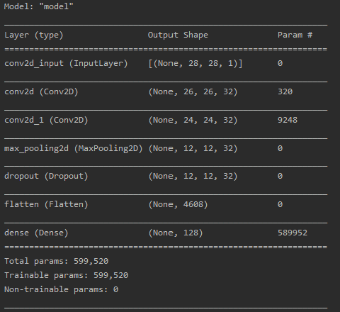 The output of the program for the following line of code  
* D – The following are the output when we calculate the ssd of the embedding of the first image with the rest of the embeddings. They are intentionally shown in the groups of 9. The first group of 9 corresponds to the embeddings for the letter alpha and the second and third correspond to beta and gamma respectively. 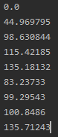 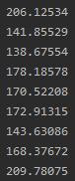 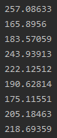 The pattern we find here is that the values in the first column are generally smaller than the values in the second and third columns. This was expected because an embedding for the letter alpha should be closer to other embeddings for the letter alpha when compared to the other letters if the embeddings are calculated are to be any useful. Though some of the values in the first column are still a bit big, this could be explained by the vastly different ways different people write the same letter.
* E – writing for this part before D because it’s used in the explanation for D. The examples used 
* E – The output of the program for these examples

1. The predicted class for this test example is alpha with the least ssd being 760.92596

And the sorted order of the ssds being [(760.92596, 'alpha'), (764.24567, 'alpha'), (767.6239, 'alpha'), (777.9092, 'alpha'), (778.0696, 'beta'), (795.68274, 'alpha'), (797.49554, 'beta'), (797.58044, 'beta'), (803.1222, 'alpha'), (803.3125, 'alpha'), (805.5499, 'gamma'), (809.4066, 'beta'), (812.85394, 'beta'), (814.4122, 'alpha'), (823.8227, 'beta'), (831.39246, 'beta'), (832.56335, 'alpha'), (850.4369, 'beta'), (854.56573, 'gamma'), (855.3436, 'gamma'), (863.0204, 'gamma'), (867.57587, 'gamma'), (884.4514, 'gamma'), (892.9863, 'gamma'), (900.6026, 'gamma'), (900.66016, 'beta'), (915.2759, 'gamma')]

1. The predicted class for this test example is alpha with the least ssd being 1218.0718

And the sorted order of the ssds being [(1218.0718, 'alpha'), (1225.8298, 'alpha'), (1297.9861, 'alpha'), (1318.3754, 'beta'), (1320.9689, 'beta'), (1325.7136, 'alpha'), (1326.834, 'alpha'), (1327.7542, 'beta'), (1329.9807, 'gamma'), (1342.2771, 'beta'), (1344.871, 'alpha'), (1346.3511, 'alpha'), (1351.2736, 'beta'), (1352.1132, 'beta'), (1355.4512, 'gamma'), (1358.2692, 'alpha'), (1376.996, 'gamma'), (1378.7351, 'beta'), (1385.5261, 'gamma'), (1388.5593, 'gamma'), (1388.727, 'beta'), (1397.1155, 'alpha'), (1404.7112, 'beta'), (1404.8633, 'gamma'), (1404.8818, 'gamma'), (1448.8042, 'gamma'), (1449.3851, 'gamma')]

1. The predicted class for this test example is beta with the least ssd being 272.33878

And the sorted order of the ssds being [(272.33878, 'beta'), (272.67413, 'beta'), (281.6898, 'beta'), (313.5133, 'beta'), (316.18677, 'beta'), (330.94016, 'beta'), (345.341, 'beta'), (346.43585, 'beta'), (348.09937, 'alpha'), (350.1725, 'beta'), (357.75873, 'alpha'), (367.60162, 'alpha'), (369.27765, 'alpha'), (370.76117, 'alpha'), (375.26306, 'alpha'), (375.7703, 'alpha'), (385.52258, 'alpha'), (396.57697, 'gamma'), (405.57764, 'gamma'), (413.77908, 'gamma'), (436.289, 'alpha'), (437.33548, 'gamma'), (442.81848, 'gamma'), (445.11383, 'gamma'), (461.91, 'gamma'), (462.3432, 'gamma'), (473.48553, 'gamma')]

1. The predicted class for this test example is beta with the least ssd being 1032.418

And the sorted order of the ssds being [(1032.418, 'beta'), (1059.4359, 'gamma'), (1062.1442, 'beta'), (1065.81, 'beta'), (1066.6863, 'beta'), (1069.636, 'beta'), (1074.1743, 'gamma'), (1074.847, 'beta'), (1076.4106, 'beta'), (1088.9434, 'alpha'), (1091.1721, 'alpha'), (1095.7346, 'beta'), (1099.2477, 'beta'), (1101.9634, 'alpha'), (1112.0942, 'gamma'), (1116.1715, 'alpha'), (1116.1895, 'gamma'), (1121.4702, 'gamma'), (1124.0642, 'gamma'), (1126.6866, 'gamma'), (1133.6013, 'alpha'), (1136.6729, 'gamma'), (1136.7668, 'alpha'), (1140.7612, 'alpha'), (1159.3481, 'alpha'), (1163.9783, 'gamma'), (1202.3268, 'alpha')]

1. The predicted class for this test example is gamma with the least ssd being 220.42996

And the sorted order of the ssds being [(220.42996, 'gamma'), (225.51855, 'gamma'), (243.57407, 'alpha'), (249.32504, 'alpha'), (249.53116, 'gamma'), (258.696, 'beta'), (261.3225, 'beta'), (265.60406, 'gamma'), (266.0514, 'alpha'), (271.86835, 'beta'), (272.53302, 'gamma'), (275.41678, 'gamma'), (276.30127, 'alpha'), (281.3958, 'alpha'), (284.76147, 'beta'), (286.06674, 'beta'), (288.13477, 'alpha'), (289.25446, 'alpha'), (304.8319, 'gamma'), (306.31436, 'beta'), (308.18982, 'beta'), (308.5205, 'beta'), (308.7435, 'gamma'), (308.80328, 'alpha'), (313.65323, 'alpha'), (318.8186, 'gamma'), (339.6079, 'beta')]

1. The predicted class for this test example is gamma with the least ssd being 105.69834

And the sorted order of the ssds being [(105.69834, 'gamma'), (119.36495, 'gamma'), (122.23416, 'gamma'), (137.2319, 'gamma'), (139.03111, 'gamma'), (139.29636, 'beta'), (141.3153, 'beta'), (149.72977, 'gamma'), (156.49487, 'beta'), (159.18347, 'beta'), (171.75308, 'alpha'), (172.75218, 'alpha'), (174.93536, 'alpha'), (182.9768, 'gamma'), (183.9507, 'gamma'), (185.98401, 'beta'), (186.14864, 'beta'), (191.73547, 'beta'), (192.89806, 'alpha'), (201.1836, 'beta'), (202.1629, 'alpha'), (209.10052, 'alpha'), (209.74527, 'alpha'), (233.25987, 'alpha'), (238.52965, 'gamma'), (247.6221, 'beta'), (301.98044, 'alpha')]

* D – a knn classifier should work pretty well for this task. As we can see from the ssds between the embedding of the test images (from part E) and the 27 embeddings the best match is not always a very small value (like see examples 1 and 2), so it’s might also be the case that the best might is not the correct match, but it’d still be very likely that the second best, third best and so on might be the correct matches, or at least majority of the top few matches would still be correct. So, overall our guess is that using knn would just make our system more robust. This robustness would be especially nice to have if we increase the number of letters in our database.

# Task 4

We’ve done this task in a Jupyter Notebook, which includes the report as well as the code for this task. Please go to the following link <https://colab.research.google.com/drive/1BV2w2xwR96jUTWYWftYOJ3dYMbXQZUwG?usp=sharing>

# Extensions

1. A generalized way to fix the first layer of the model (i.e. make it untrainable) and initialize it with any kind of filter. We build this mainly to initialize the first layer with a set of Gabor filters, but just to show the capability of our system to work with any type of filters we also implement Gaussian filters. This system along with being capable of being trained and tested, also has the ability to perform all the sub-tasks of task, i.e. we can easily analyze the layers of the system or the outputs for the layers, etc.
   * The plot of the filters 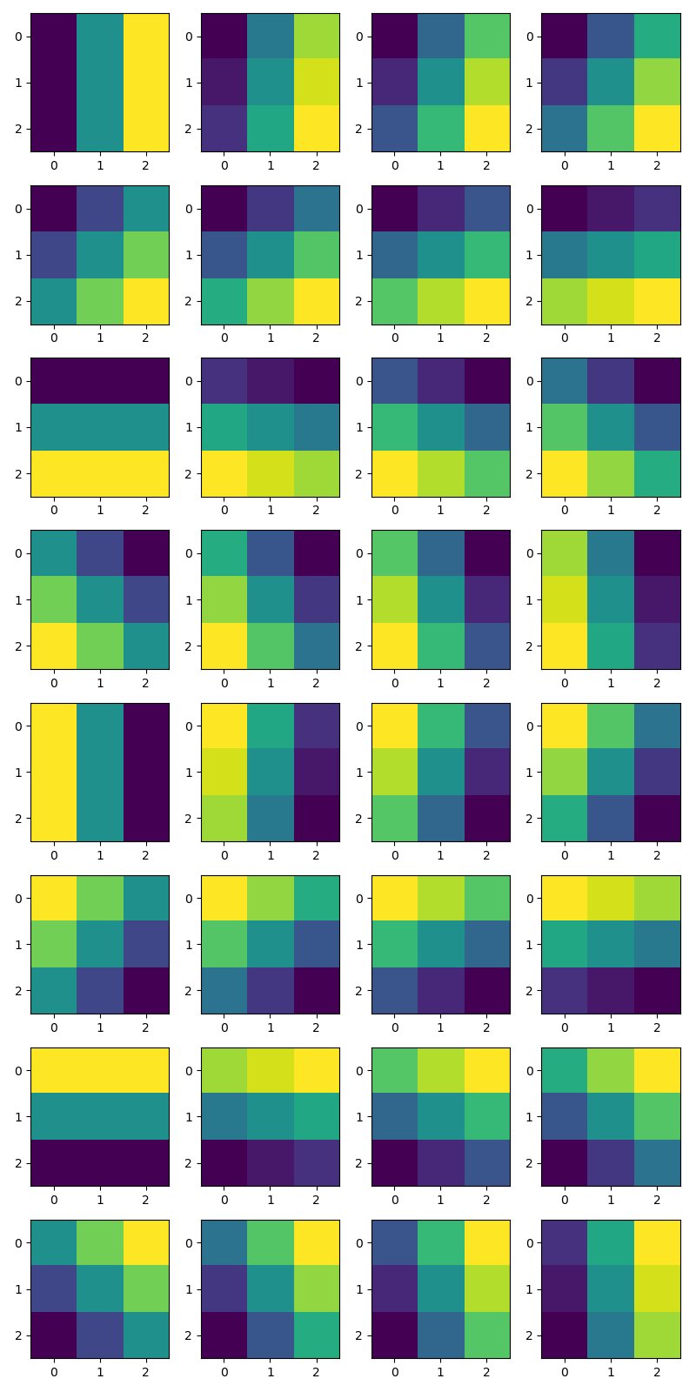
   * While making the Gabor filters we only vary the orientation of the filter but keep the rest of the parameters fixed. These can easily be changed in the code though. We make the filters by dividing a whole 360 degree angle into c number of parts (where c in the number of filters required).
   * The output of the first layer of Gabor filters. And we can see that the output shows that each filter detects a certain kind of change in the pixel intensity or a certain orientation of edge. 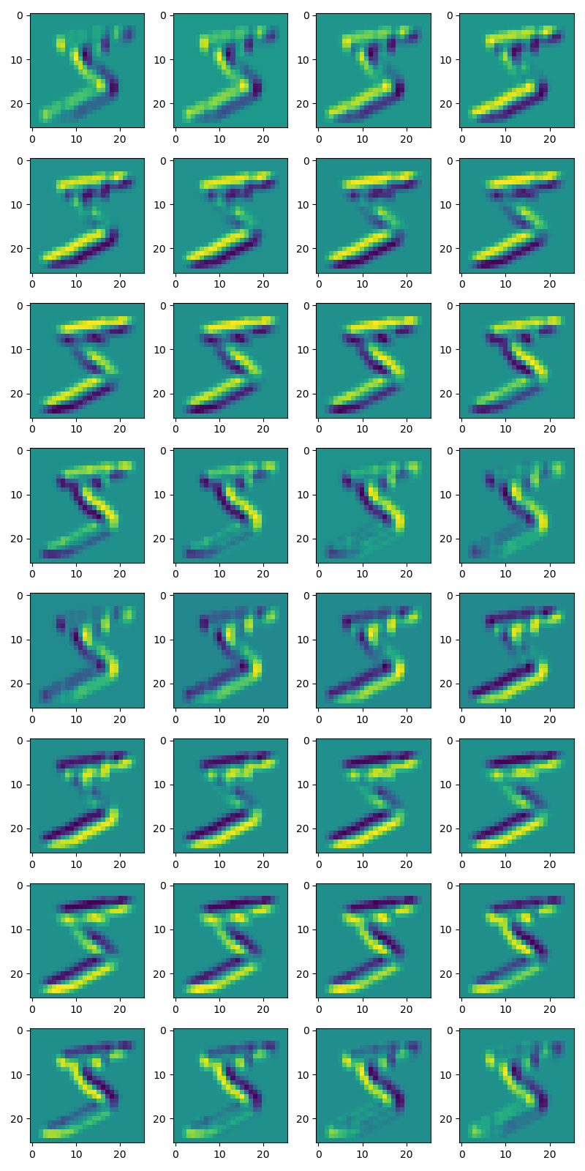
   * The output of the pooling layer for the 10th example (just to showcase that we can plot the output of any layer for any example we wish) 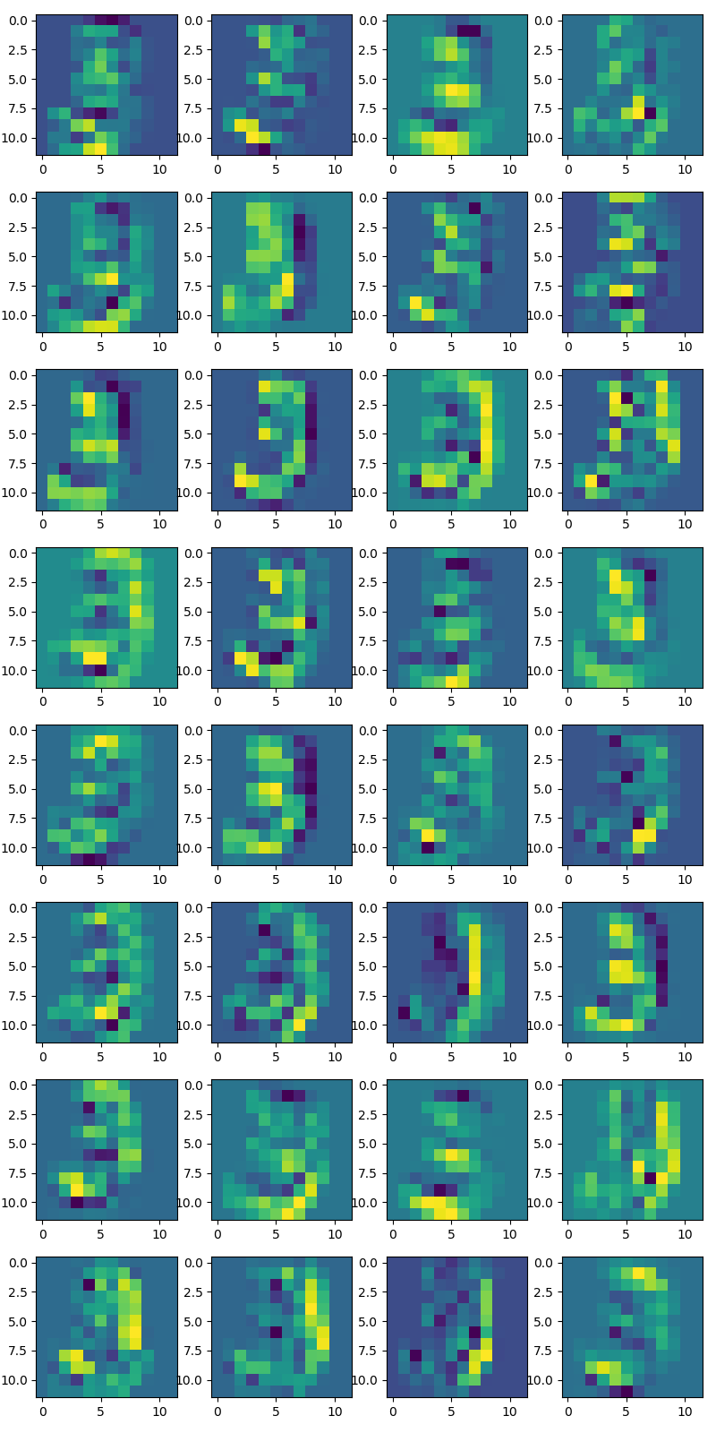
   * Values of the filters (only showing the first few, the complete list can be found in the out.txt file of the extension)

tf.Tensor(

[[-5.6526756e-01 6.0755827e-17 5.6526756e-01]

[-5.6970102e-01 6.1232343e-17 5.6970102e-01]

[-5.6526756e-01 6.0755827e-17 5.6526756e-01]], shape=(3, 3), dtype=float32)

tf.Tensor(

[[-6.4183843e-01 -1.2121242e-01 4.5981041e-01]

[-5.6069291e-01 6.1232343e-17 5.6069291e-01]

[-4.5981041e-01 1.2121242e-01 6.4183843e-01]], shape=(3, 3), dtype=float32)

tf.Tensor(

[[-6.9218397e-01 -2.3547406e-01 3.2611090e-01]

[-5.3338838e-01 6.1232343e-17 5.3338838e-01]

[-3.2611090e-01 2.3547406e-01 6.9218397e-01]], shape=(3, 3), dtype=float32)

tf.Tensor(

[[-7.2021389e-01 -3.3692095e-01 1.6950892e-01]

[-4.8714474e-01 6.1232343e-17 4.8714474e-01]

[-1.6950892e-01 3.3692095e-01 7.2021389e-01]], shape=(3, 3), dtype=float32)

…

* + The accuracy of this model on the custom hand written digits is 100%. The output of the program: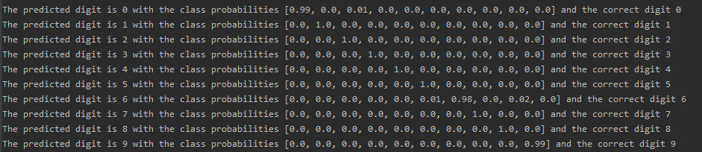
  + The same outputs for the model with gaussian filters can be seen by running the FirstLayerFixed.py file, but ensure that the folder contains gaussian_model.h5 or that the load_model parameter is set to False.

1. TODO write about the other extension here
2. The code for loading the images for the greek alphabets and creating a database out of it is generic enough that we can just add images for new alphabets and run the code, and it would just work without making any changes to the code. The only thing we need to ensure is that we’re putting in the alphabets in the greek folder inside task3, and that the files follow the same naming convention as before which is the class name followed by an underscore followed by a number.

# Reflection, Learnings

TODO

# References

1. StackOverflow
2. Python documentation
3. Lectures and notes
4. Keras Tutorials
5. OpenCV tutorials
6. We also mention the specific links in the code if that part of the code was heavily inspired off that source.